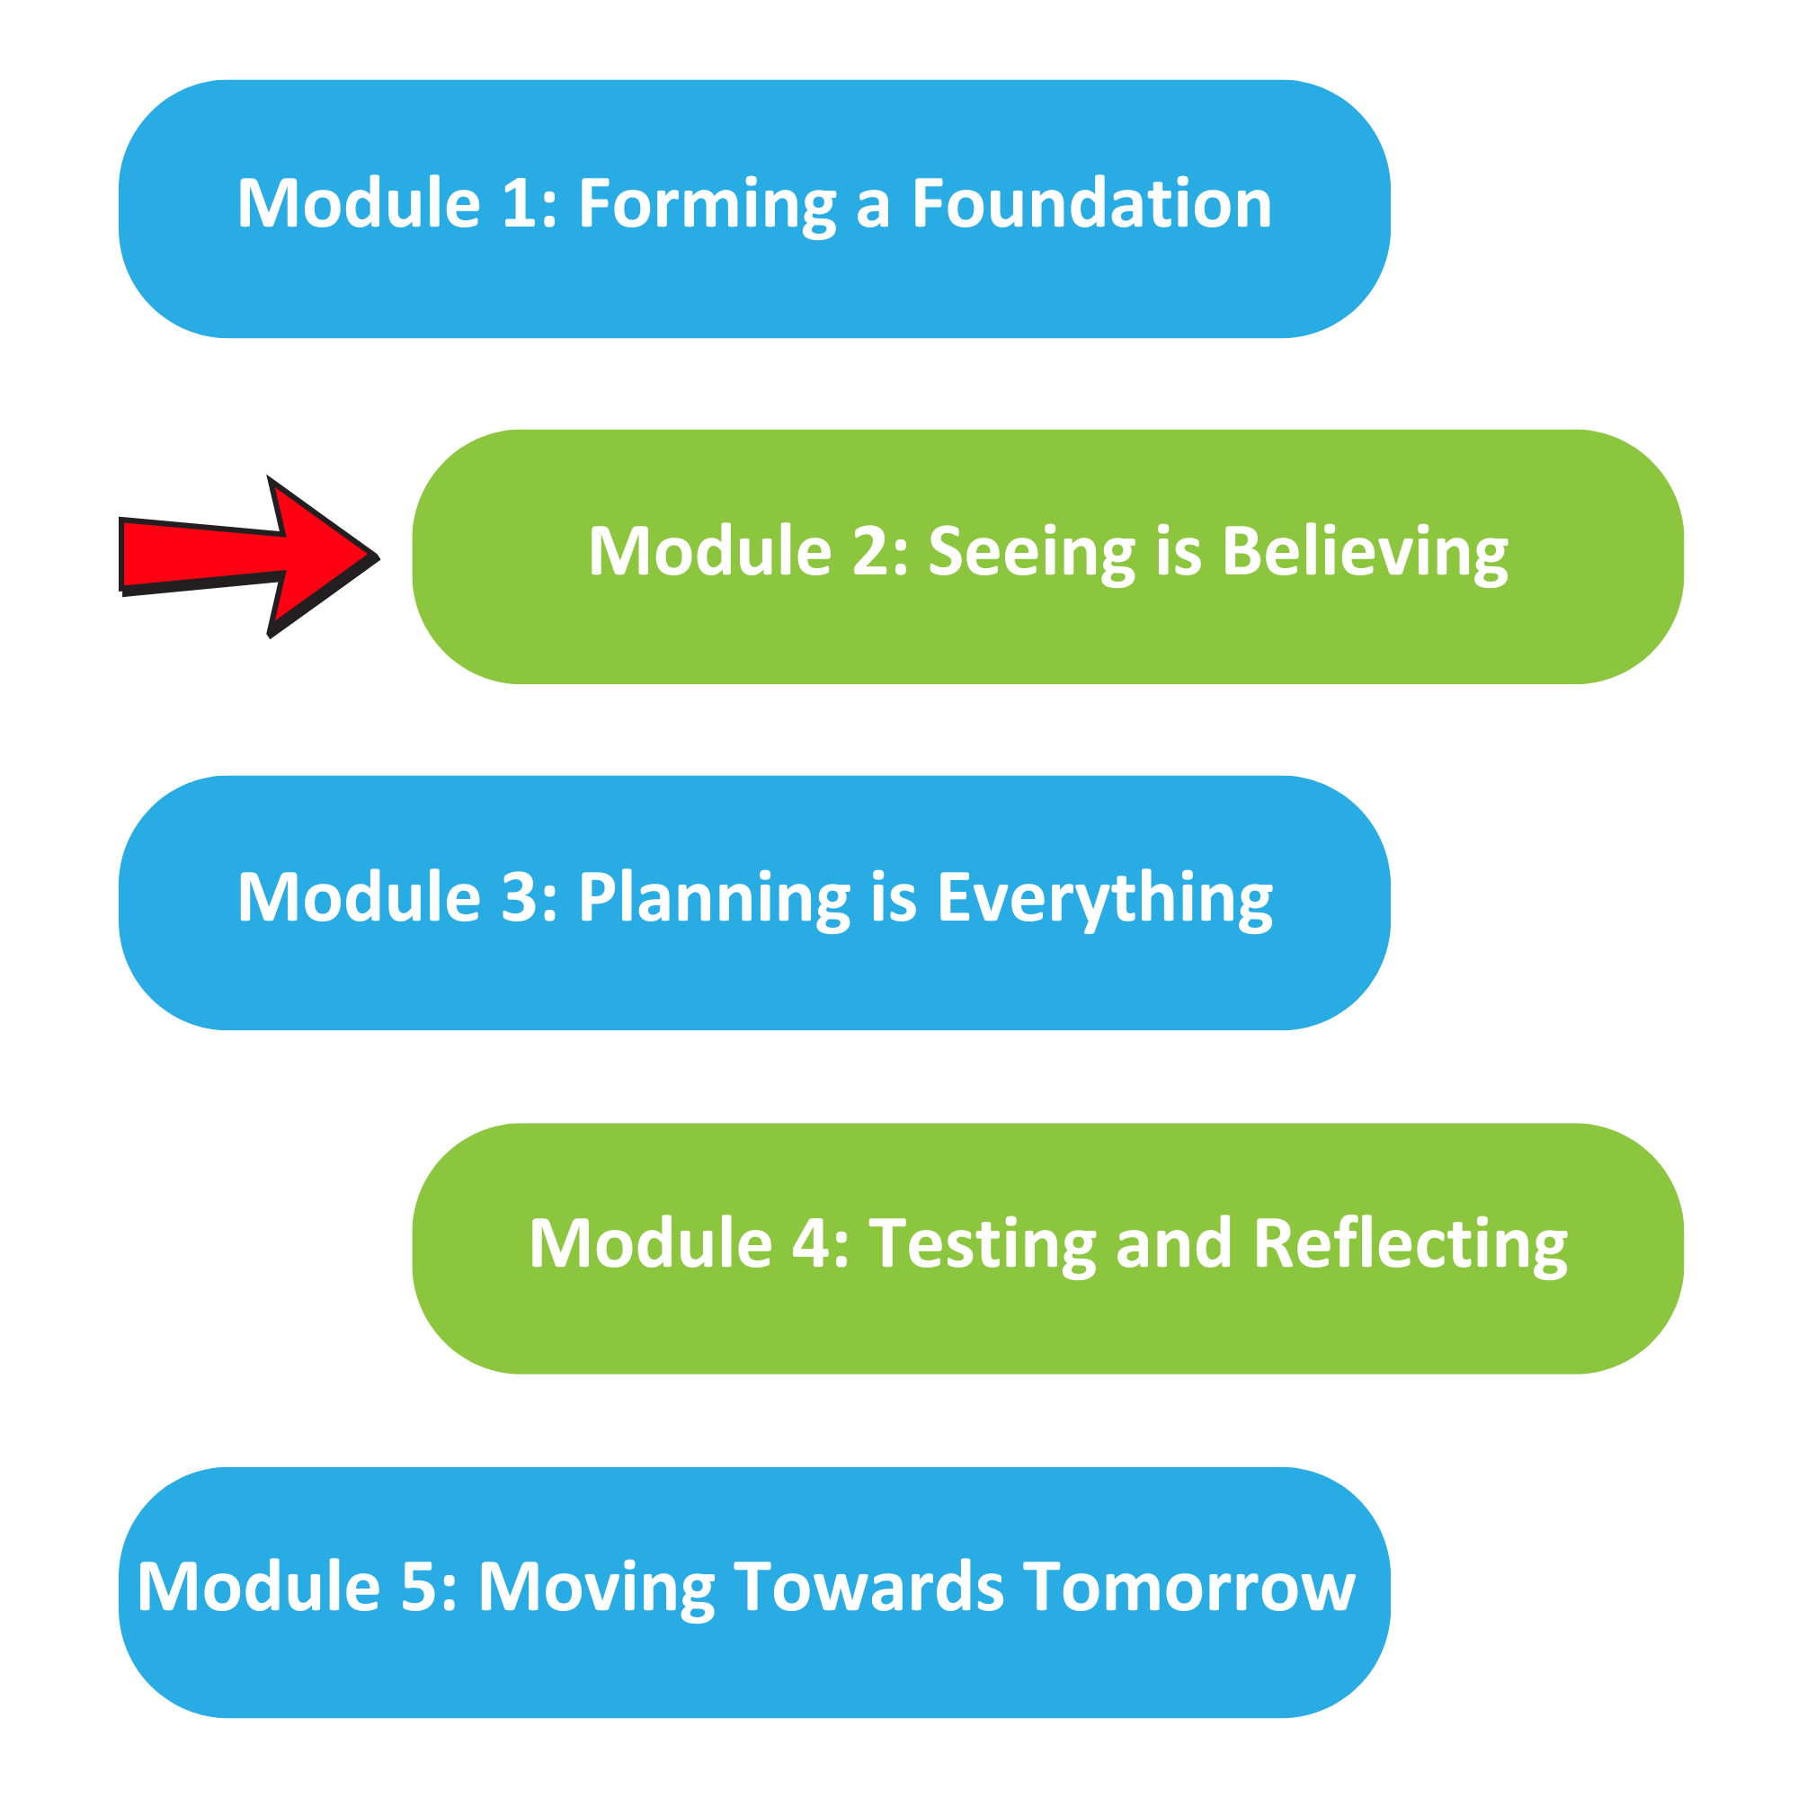

The Well Planned Action Series is a grassroots education and action program consisting of five modules completed over five months by multidisciplinary teams across the Island Health region. We are all focused on the same goal: Improve the experience for people who are creating, communicating, and clarifying medical goals for discharge! Medical goals for discharge provide information about the reason for a patient’s admission and describe the clinical status the team and patient are working towards.

In Module 2, we learned:

The process involved in creating, communicating, and clarifying medical
goals for discharge from each perspective

How the team’s roles, skills and workload differ

How to identify opportunities for improvement within our sphere of
control

Team Name: ____________________________________

One thing that stood out for us:
(Highlight something you learned from your Well Planned Explorer conversations)

What we discovered as a team:
(Opportunities for improvement within the Well Planned Team’s sphere of control)

What our team wants everyone else on this (unit/clinic/floor) to know:

If you are interested in learning more, contact:
(Insert Action Series Team members’ name and best way to contact them)

