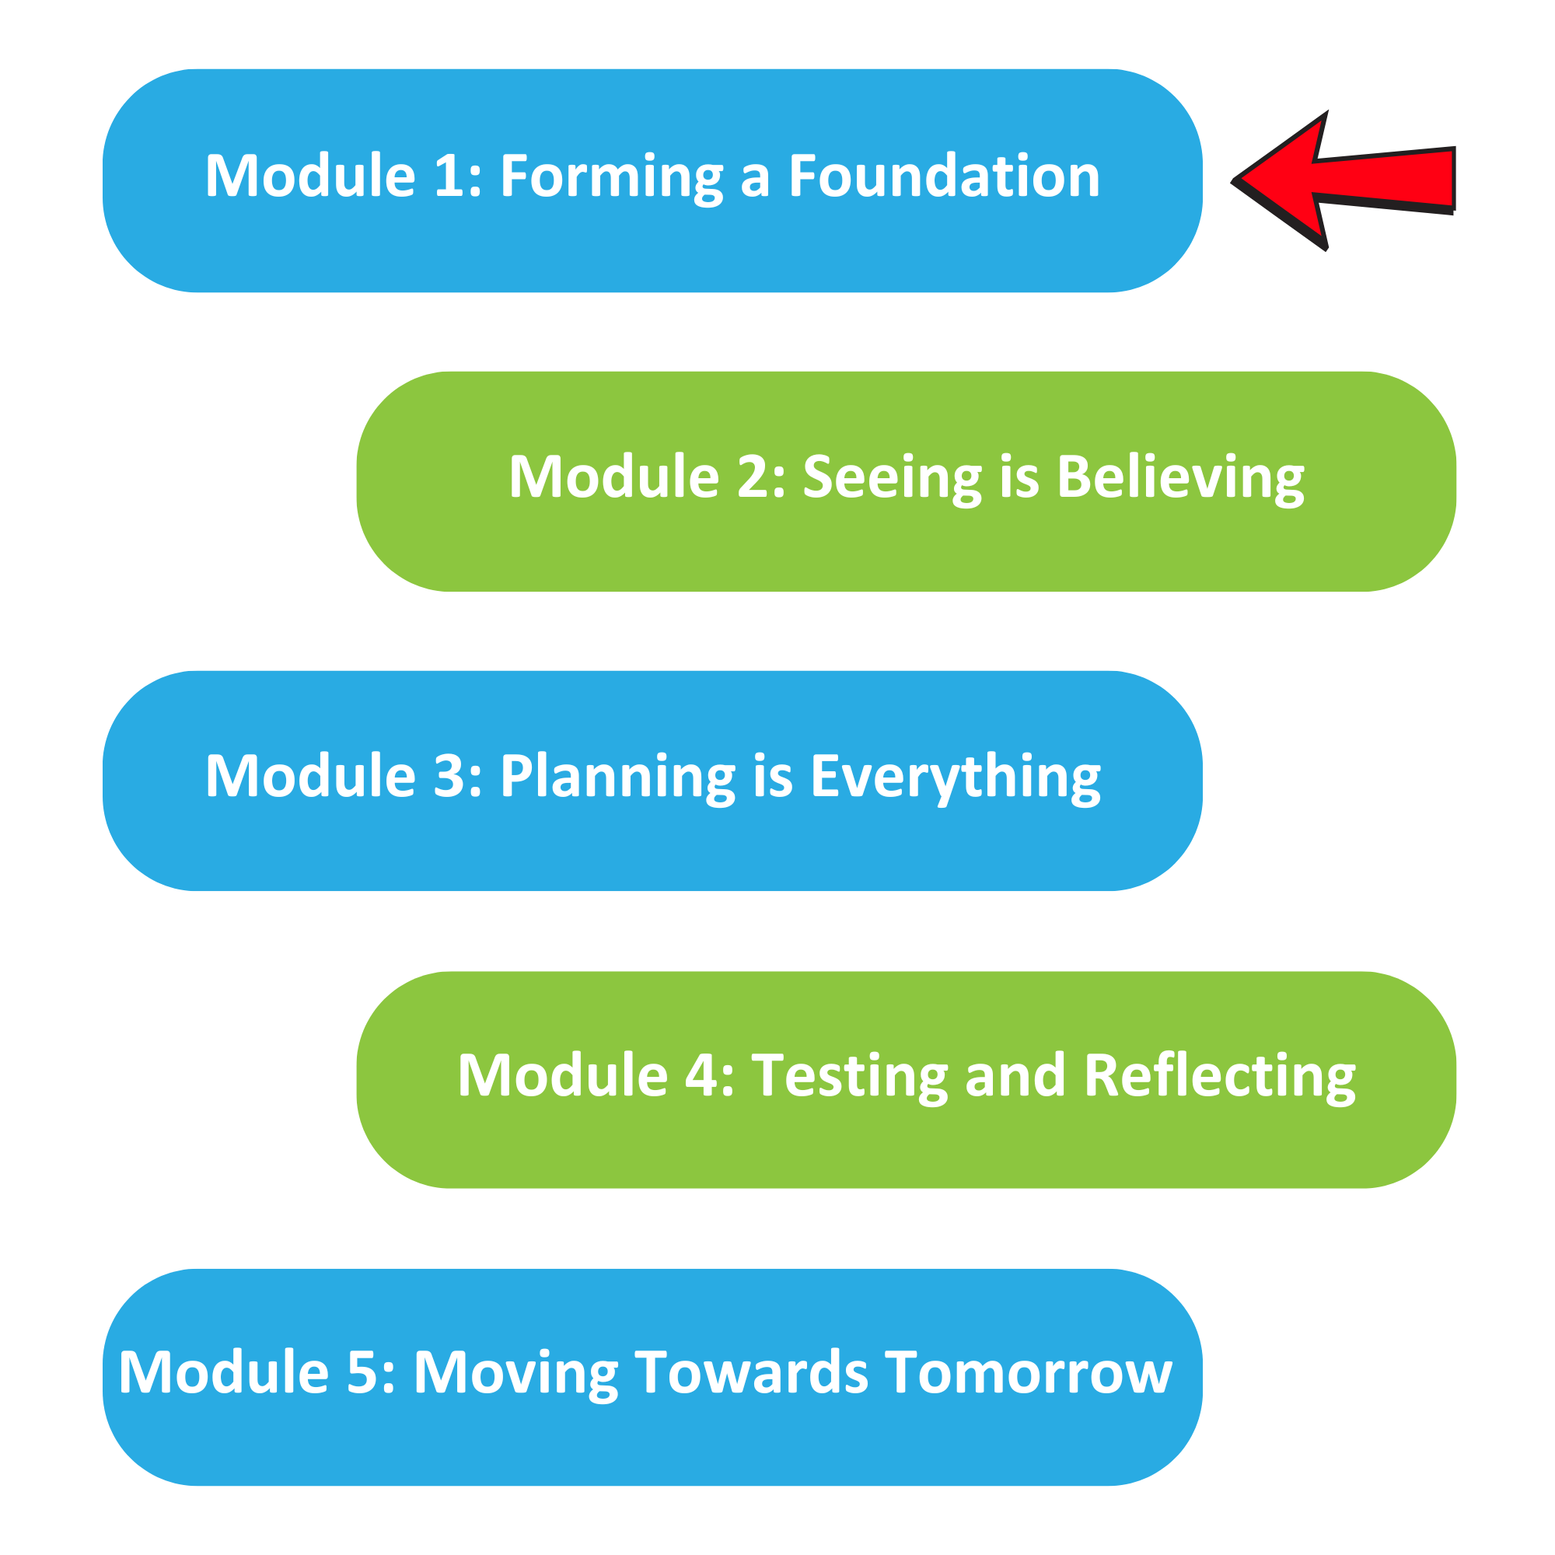

The Well Planned Action Series is a grassroots education and action program consisting of five modules completed over five months by multidisciplinary teams across the Island Health region. We are all focused on the same goal: Improve the experience for people who are creating, communicating, and clarifying medical goals for discharge! Medical goals for discharge provide information about the reason for a patient’s admission and describe the clinical status the team and patient are working towards.

In Module 1, we learned:

How to create awareness and engage the broader team

How and why a united team approach improves patient care

How to identify our core values and vision as a team

Team Name: ____________________________________

One thing that stood out for us:
(If you’re stumped, pick out something from the learning objectives or go back to the videos and go from there!)

What we did as a team:
(Share your team vision or your common values!)

What our team wants everyone else on this (unit/clinic/floor) to know:

Ways we will communicate this update:
(Think of where information is already shared. Binder? Notice board? Email? Huddle? Nursing station?)

