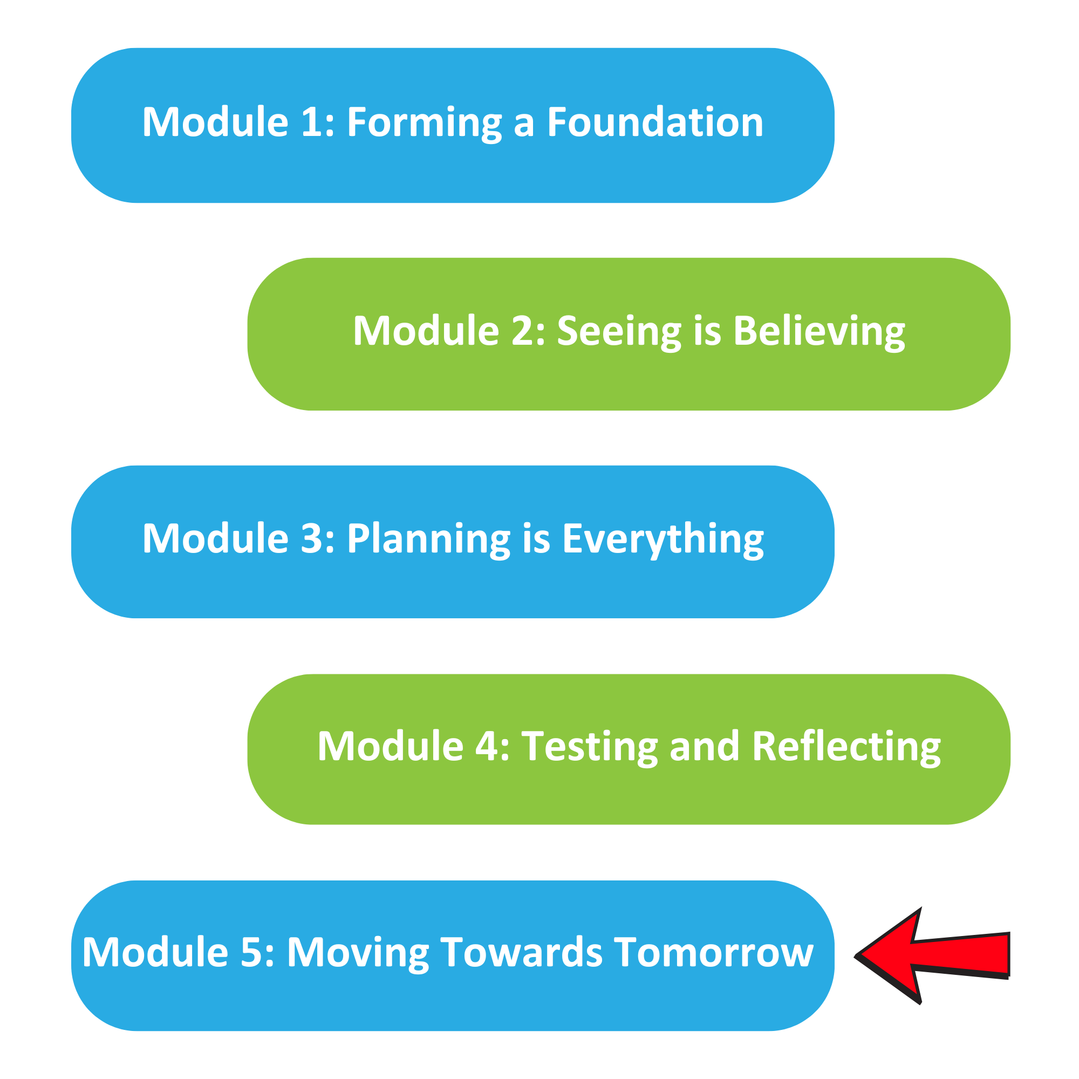

The Well Planned Action Series is a grassroots education and action program consisting of five modules completed over five months by multidisciplinary teams across the Island Health region. We are all focused on the same goal: Improve the experience for people who are creating, communicating, and clarifying medical goals for discharge! Medical goals for discharge provide information about the reason for a patient’s admission and describe the clinical status the team and patient are working towards.

In Module 5, we:
- Identified our key learning from the Action Series
- Identified our next steps for sustaining the gains and spreading the success
- Celebrated completing the Action Series as a team!

Team Name: ____________________________________

What we did as a team:
(What changes did you try, how did they go)

One thing that stood out for us:
(Your team’s biggest “A-ha moment”)

What our team wants everyone else on this (unit/clinic/floor) to know:
(What do you want to spread, who do you think would benefit from doing the next round of the Action Series)

