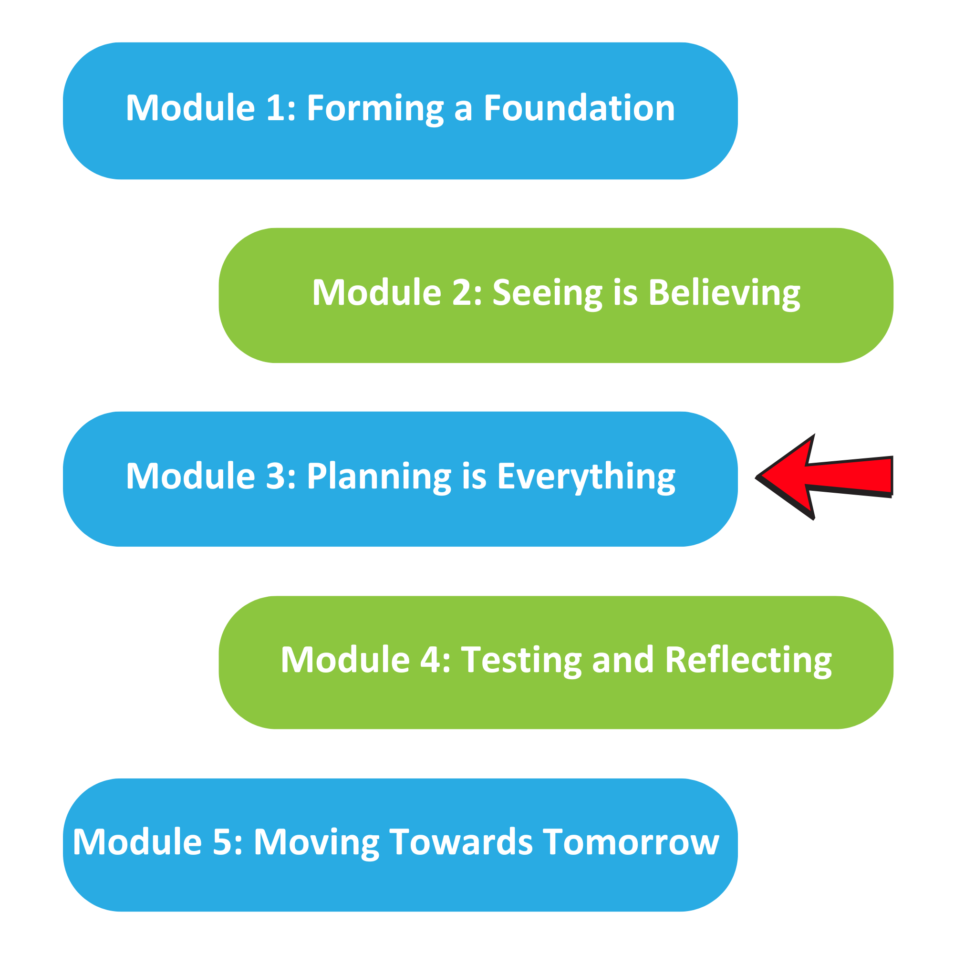

The Well Planned Action Series is a grassroots education and action program consisting of five modules completed over five months by multidisciplinary teams across the Island Health region. We are all focused on the same goal: Improve the experience for people who are creating, communicating, and clarifying medical goals for discharge! Medical goals for discharge provide information about the reason for a patient’s admission and describe the clinical status the team and patient are working towards.

In Module 3, we learned:

How to work together to identify opportunities for improvement
- How to prioritize the change ideas we want to test that are within our sphere of control and influence

Team Name: ____________________________________

What we did as a team:
(Highlight something you learned)

One thing that stood out for us:
(What you discovered using the Impact/Effort Matrix)

What our team wants everyone else on this (unit/clinic/floor) to know:

If you are interested in learning more, contact:
(Insert Action Series Team members’ name and best way to contact them)

