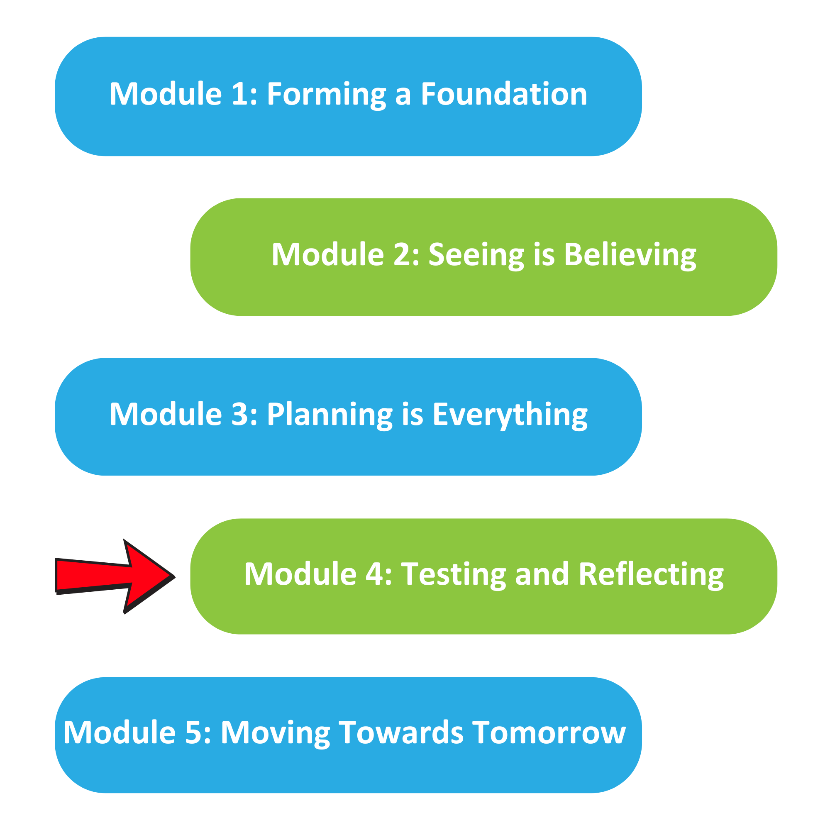

The Well Planned Action Series is a grassroots education and action program consisting of five modules completed over five months by multidisciplinary teams across the Island Health region. We are all focused on the same goal: Improve the experience for people who are creating, communicating, and clarifying medical goals for discharge! Medical goals for discharge provide information about the reason for a patient’s admission and describe the clinical status the team and patient are working towards.

In Module 4, we learned:

How to test a process of relevance to the team

How to assess the impact of the change and decide next steps

Team Name: ____________________________________

What we did as a team:
(What tests of change you tried)

One thing that stood out for us:
(What you learned from the tests, which tools you are interested in trying)

What our team wants everyone else on this (unit/clinic/floor) to know:

