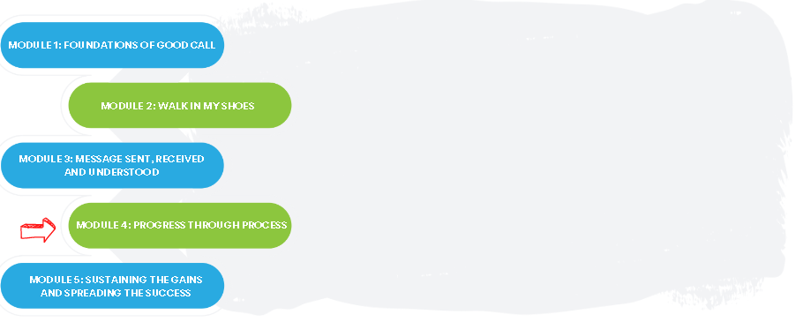

The Good Call Action Series is a grassroots education and action program consisting of five modules completed over five months by interdisciplinary teams across the Island. We are all focused on the same goal: improve the call experience in our local area by focusing how our team communicates!

In Module 4, we learned:
- How to identify pain points and opportunities for improvement using a process map
- How to prioritize the change ideas we want to test that are within our sphere of control and influence

Team Name: ____________________________________

What we did as a team:
(What tests of change you tried)

One thing that stood out for us:
(What you learned from the process map, which tools you are interested in trying)

What our team wants everyone else on this (unit/clinic/floor) to know:

If you are interested in learning more, contact:
(Insert Action Series Team members’ names and best way to contact them)

