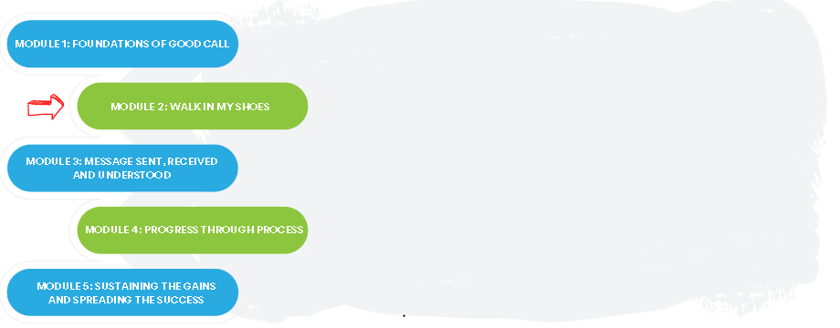

Team Name: ____________________________________

The Good Call Action Series is a grassroots education and action program consisting of five modules completed over five months by interdisciplinary teams across the Island. We are all focused on the same goal: improve the call experience in our local area by focusing how our team communicates!

In Module 2, we learned:

The process involved in on-call communication from each perspective

How the team’s roles, skills, and workload differ

How to identify opportunities for improvement within our sphere of control

One thing that stood out for us:
(Highlight something you learned from your Good Call Detective conversations)

What we discovered as a team:
(Opportunities for improvement within the Good Call Team’s sphere of control)

What our team wants everyone else on this (unit/clinic/floor) to know:

If you are interested in learning more, contact:
(Insert Action Series Team members’ names and best way to contact them)

