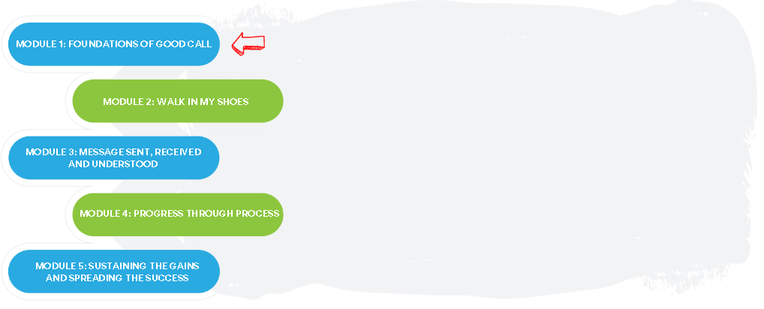

The Good Call Action Series is a grassroots education and action program consisting of five modules completed over five months by interdisciplinary teams across the Island. We are all focused on the same goal: improve the call experience in our local area by focusing on how our team communicates!

In Module 1, we learned:

How to create awareness and engage the broader team to improve call

How and why miscommunication happens in our work

How to identify our core values and vision as a team

One thing that stood out for us:
(If you’re stumped, pick out something from the learning objectives or go back to the videos and go from there!)

What we did as a team:
(Share your team vision or your common values!)

Team Name: ____________________________________

What our team wants everyone else on this (unit/clinic/floor) to know:

Ways we will communicate this update:
(Think of where information is already shared. Binder? Notice board? Email? Huddle? Nursing station?)

