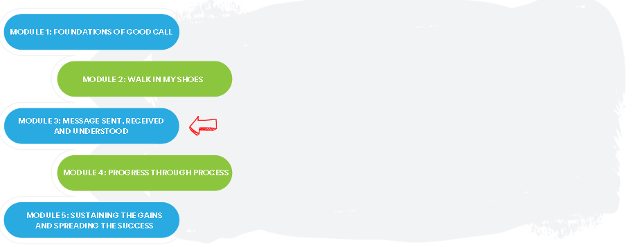

Team Name: ____________________________________

The Good Call Action Series is a grassroots education and action program consisting of five modules completed over five months by interdisciplinary teams across the Island. We are all focused on the same goal: improve the call experience in our local area by focusing how our team communicates!

In Module 3, we learned:
- How to apply QI methodology to implement/improve the use of communication tools in clinical team interactions (e.g. SBAR, CUS)
- How to implement a structured debrief tool to measure effectiveness of on-call communication (e.g. STOP)

What we did as a team:
(What tests of change you tried)

One thing that stood out for us:
(What you learned using SBAR, STOP or CUS)

What our team wants everyone else on this (unit/clinic/floor) to know:

If you are interested in learning more, contact:
(Insert Action Series Team members’ names and best way to contact them)

