The PDSA Cycle is a method of trying a change on a temporary basis and learning about its potential impact. It can be used to answer the question, “How will we know that a change is an improvement?”
Key tips for testing a change using a PDSA Cycle:
- Test on a really small scale (e.g., start with one patient or one clinician at one afternoon clinic, and increase as you refine the ideas).
- Test the proposed change with people who believe in the improvement. Don’t try to convert people into accepting the change at this stage.
- Document! Use a PDSA Worksheet to make sure you have thoroughly planned the test.

Cycle: |  | Start Date: |  | End Date:

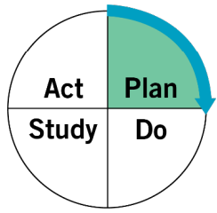 | PLAN: Plan the test, including a plan for collecting data.

STEP 1: Select a change idea from your driver diagram.

STEP 2: Turn your change idea into a question, and predict what will happen.
What is the question you are answering by testing this change idea?
What do you predict will happen?

STEP 3: List the tasks needed to test this change.
Who, and how will you make this change happen? What needs to happen before this change can be tested?
Task |  | Responsible Person | Due Date
1
2
3
4

STEP 4: Create the PDSA Cycle measurement plan.
Review your Project Measures (i.e., Family of Measures or Global Measures) that are being measured for the duration of the project. Ask yourself - is there additional data that needs to be collected during this change in order to see if there is an improvement? Document what needs to be measured ONLY for this test of change.
PDSA Cycle Measure Description | Data Source  (e.g., an individual, a survey, a check-sheet, an EMR, etc.) | Who Collects?  (e.g., responsible for collecting and storing data) | When?  (e.g., once, weekly, every instance in x timeframe)

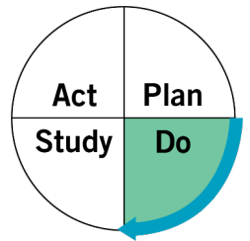 | DO: Run the test on a small scale.  Describe what happened. What data did you collect? What observations did you make?

Was the cycle carried out as planned (yes, no)?
What did you observe (i.e., include quantitative measures and qualitative feedback from the team)?
What did you observe that was not part of the plan?

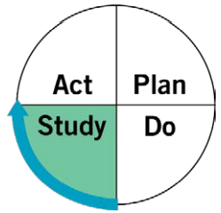 | STUDY: Analyze the results and compare them to your predictions. Summarize and reflect on what you learned.

Was your goal achieved (yes, no)? | Yes.  - Do you plan to expand the test (yes, no)?  - Will you expand the scale (i.e., keep the same conditions, just test more)  - And/or scope (i.e., change the conditions)? | [Enter summary of your analysis]
No.
- What data do you have to distinguish if your method of testing the change failed or if the designed change was not effective?
How do results of this test compare to previous performance?
Were there any barriers with the cycles’ implementation (yes, no)?
What else did you learn?

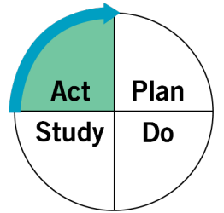 | ACT: Based on what you learned from the test, make a plan for your next step.  Determine what modifications you should make — adapt, adopt, or abandon.

 | ABANDON: Discard change idea testing. Describe what you will change. | [Enter plan for next step]
 | ADAPT: Improve the change & continue a larger scale. Develop an implementation plan for sustainability.
 | ADOPT: Select changes to implement on & try a new one

