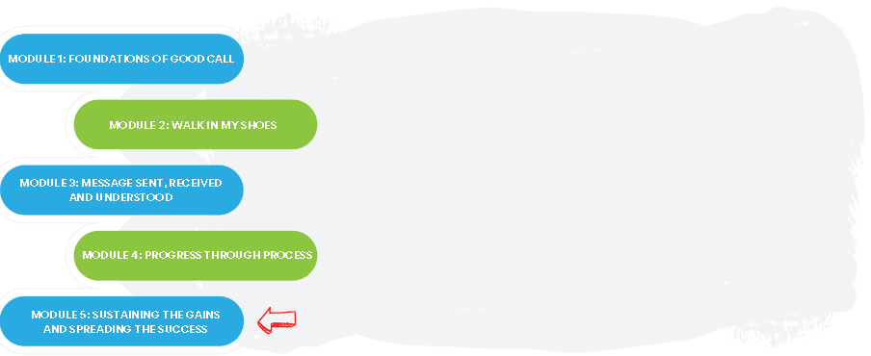

The Good Call Action Series is a grassroots education and action program consisting of five modules completed over five months by interdisciplinary teams across the Island. We are all focused on the same goal: improve the call experience in our local area by focusing on how our team communicates!

In Module 5, we:
- Identified our key learning from the Action Series
- Identified our next steps for sustaining the gains and spreading the success
- Celebrated completing the Action Series as a team!

Team Name: ____________________________________

What we did as a team:
(What changes did you try, how did they go))

One thing that stood out for us:
(Your team’s biggest “A-ha moment”)

What our team wants everyone else on this (unit/clinic/floor) to know:
(What do you want to spread, who do you think would benefit from doing the next round of the Action Series)

